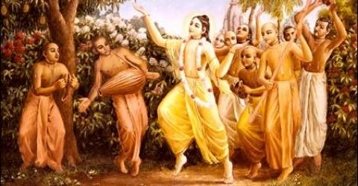
Soldiers of Godhead
July 2010 Special Edition.
To subscribe for free monthly editions, write into, vinay.chakraborty@yahoo.com or visit www.soldiersofgodhead.yolasite.com
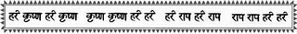
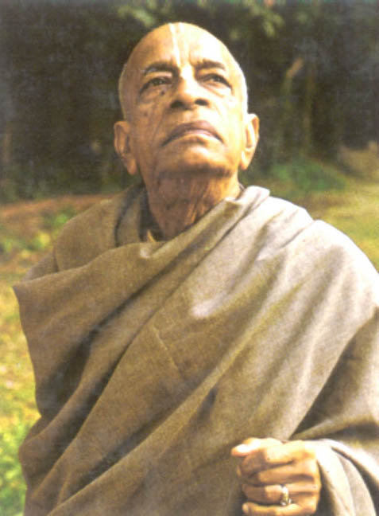
This month’s edition is especially dedicated to His Divine Grace, A.C. Bhaktivedanta Swami Prabhupada. In July of 1966, Srila Prabhupada established the International Society for Krishna Consciousness (ISKCON), in New York City, US. I humbly dedicate this month’s edition to the General of the Soldiers of Godhead. Hare Krishna!

Sr.no Contents Pg no.
- Birth and Early years. 4

- Meeting his Spiritual Master. 6

- Retirement from material life. 9

- On a mission to America. 11

- Establishment of the Hare Krishna Movement. 14

- Final years and His legacy. 21

1.Birth and Early years
Born on September 2nd, 1886 in Calcutta, West Bengal, India, His family name was Abhaya Charan De. He was born on the following day of Janamashthami (Appearance day of Lord Sri Krishna) in a vaishnava family and since his early years his father trained him in vaishnava principles. He would regularly go with his father to the local Radha- Krishna temple and would offer puja at home to the deity. At the age of 16, his father thought him to play the Mridanga (A musical instrument played with both hands during Kirtans or congressional singing of the Lord’s glories.)
As a young boy he was fascinated by seeing the Rath Yatra of Lord Jagganatha. (Lord Sri Krishna) This laid the foundation of his spiritual pursuits in life, which have today benefitted millions around the globe. After completing high school, he was enrolled at the highly reputed Scottish churches college, Calcutta. He graduated in 1920 with majors in English, Philosophy and Economics. However he refused to accept his diploma, being a devout follower of Gandhi at the time. His refusal to accept the diploma he had earned was in protest of the British. He also wore the homespun cotton cloth the followers of Gandhi wore in protest of British clothes. Hare Krishna!
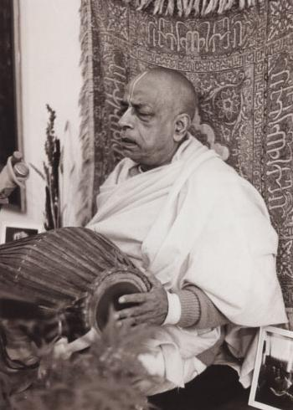
Srila Prabhupada playing a Mridanga at a sankirtan.

2.Meeting his Spiritual Master.
In 1922 just two years after his graduation, he met his future spiritual master Sri Srimad Bhaktisiddhanta Sarasvati Goswami Maharaj Prabhupada. In the very first meeting of the two, Srila Bhaktisiddhanta Sarasvati Maharaj asked young Abhaya, not to follow Gandhi but to spread the teachings of Chaitanya Mahaprabhu in English for a western audience. In 1932, he became a formally initiated disciple of Srila Bhaktisiddhanta Sarasvati Thakur and in 1944 he started his magazine Back to Godhead which he wrote, edited, published and distributed himself. He personally designed the logo, an effulgent figure of Chaitanya Mahaprabhu in the upper left corner, with the motto: "Godhead is Light, Nescience is darkness" greeting the readers. In his first magazine he wrote:
“Under the circumstances since 1936 up to now, I was simply speculating whether I shall venture this difficult task and that without any means and capacity; but as none have discouraged me, I have now taken courage to take up the work.” — A.C.Bhakivedanta Swami, Back to Godhead magazine(Vol.1, 1-4, 1944).
In 1947, the Gaudiya Vaishnava Society recognized Srila Prabhupada’s scholarship with the title “Bhaktivedanta” which means, “devotional service is the goal of knowledge.” His later
Name, “Prabhupada” means “the one who holds the position of God.” This name was used as a respectful form of address by his disciples from late 1967 early 1968 onwards. Previous to this, as with his early disciples, followers used to call him “Swamiji”. 1950 onwards, Srila Prabhupada began to stay at the Radha Damodar temple in Vrindavan, India. It was here where he began the work on his life’s masterpiece, the translation of the Srimad Bhagavatam (Bhagavat Puran) of 18ooo verses and 12 cantos. His spiritual master always told him, “if you ever get money, print books”. This way Srila Bhaktisiddhanta Sarasvati Thakur Prabhupada would always encourage his disciple and stress the importance of book distribution and the use of modern technologies to spread Krishna Consciousness.
Hare Krishna!
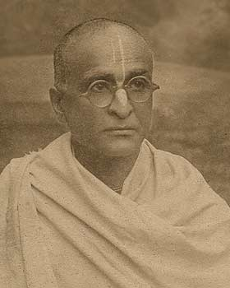
Srila Bhaktisiddhanta Sarasvati Thakur Prabhupada. Spiritual Master of Srila Prabhupada.

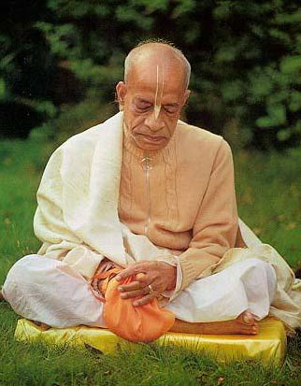

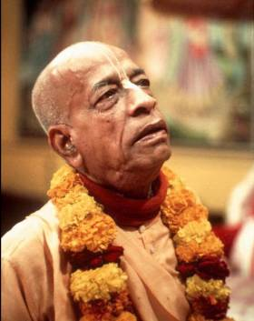
3. Retirement from material life

Srila Prabhupada used to live at the Keshavaji Gaudiya Matha. He had studied and written in the library of the building. Here he edited the Gaudiya Patrika magazine and this is the place where he donated the murti of Lord Chaitanya who stands on the Altar next to Radha Krishna named Sri Sri Radha Vinodavihariji. During his visit in September 1959 he entered the doors of this matha dressed in white, as Abhay Babu, but would be leaving dressed in saffron, a Swami. In this matha, in Mathura, Vrindavana, Prabhupada took Vaishnava renunciate vows, sanyasa, from his friend and godbrother Bhakti Prajnana Keshava Maharaja, and following this he single handedly published the first three volumes covering seventeen chapters of the first book of Bhagavata Purana, filling three volumes of four hundred pages each with a detailed commentary. Introduction to the first volume was a biographical sketch of Chaitanya Mahāprabhu. He then left India, obtaining free passage on a freight ship called the Jaladuta, with the aim and a hope of fulfilling his spiritual master's instruction to spread the message of Chaitanya Mahaprabhu around the world. In his possession were a suitcase, an umbrella, a supply of dry cereal, about eight dollars worth of Indian currency and several boxes of books.

Hare Krishna!
4. On a mission to America
During his travels between Delhi and Vrindavan in connection of the printing work of his magazine, Srila Prabhupada thought that the Indian population was imitating the westerners and forgetting the roots of their own culture. People around the world were following the trends in America. Hence, he decided to go to America and train disciples there so that Indians and the people around the world would imitate them and take to devotional service to Lord Sri Krishna.
“I do not know why You have brought me here. Now You can do whatever You like with me. But I guess You have some business here, otherwise why would You bring me to this terrible place? How will I make them understand this message of Krishna consciousness? I am very unfortunate, unqualified and most fallen. Therefore I am seeking Your benediction so that I can convince them, for I am powerless to do so on my own.” -A.C.Bhaktivedanta Swami, onboard the Jaladuta

In septermber of 1965, Srila Prabhupada sailed to America onboard the freight ship ‘ Jaladuta’, to fulfill the wish of his spiritual master of preaching Gaudiya Vaishnavism in the west. His trip to the United States was not sponsored by any religious organization, nor was he met upon arrival by a group of loyal followers. As he neared his destination on the ship, the Indian freighter Jaladuta, the enormity of his intended task weighed on him. On September 13 he wrote in his diary, "Today I have disclosed my mind to my companion, Lord Sri Krishna”. On this occasion and on the number of other, Prabhupada, called on Krishna for help in his native Bengali. Examining these compositions, academics regard them as "intimate records of his prayerful preparation for what lay ahead" and a view on "how Bhaktivedanta Swami understood his own identity and mission."
Taking up such a task at the age of 70 was a very bold move by Srila Prabhupada. His journey to the west was one filled with difficulties at every step. During his voyage, he got sea sick and later suffered two heart attacks. Still, not letting any weakness overpower his faith, he continued on his mission. And it was this remarkable display of strength that showed his unflinching faith in the holy name of Krishna and his dedication and sincerity towards his spiritual master.

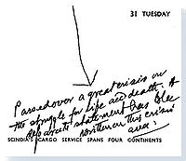
A message from Jaladuta Diary Journal kept by Prabhupada. Between August 25, 1965 and August 30, 1965, the Jaladuta Journal falls silent for six days. On the seventh day, August 31, the silence is broken with these simple words, “Passed over a great crisis on the struggle for life and death.”
The Jalalduta arrived at Boston harbor on september the 17th 1965. Upon arrival, he stayed with the family of the son of a friend of his for a month at Philadelphia. Later he thought that the Krishna Consciousness movement must start at a prominent location. Hence, he established the Hare Krishna Movement in New York City in July of 1966 after nearly a year of struggle. His initial followers consisted of youngsters who during that period were under the influence of the cultural revolution and the hippie movement. Srila Prabhupada converted these hippies and other bewildered souls into pure devotees of Lord Krishna.
Hare Krishna!
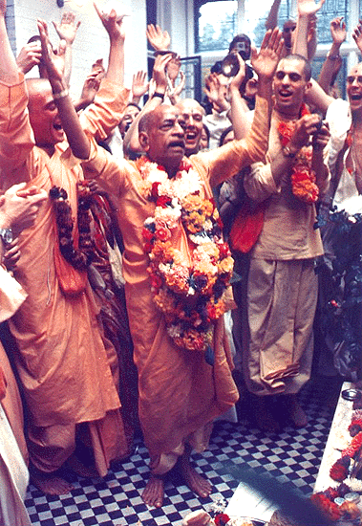
5.Establishment of the Hare Krishna Movement

Having founded the Hare Krishna Movement in New York City, Srila Prabhupada soon began a campaign for the expansion of the movement. In 1967, he visited San Francisco, California and conducted Kirtans and discourses, thus sowing the seeds of devotion among the hippies and others who benefitted from the movement. From here, he travelled throughout America and popularized street chantings, book distributions and discourses.
After being well established in America, Srila Prabhupada decided to spread the message of Lord Chaitanya in Europe. He sent a group of devotees to London, England and asked them to preach Lord Chaitanya’s message of Bhakti (devotional service to Lord Krishna) there. Having arrived in London with no facilities such as residence or transportation, by Krishna’s grace they somehow got in touch with George Harrison who was a member of the beatles at the time. He took deep interest in the Gaudiya Vaishnava philosophy and the Bhakti movement. He decided to make a record with them of the Hare Krishna Maha Mantra. It became an instant hit and thus a success report was sent to Srila Prabhupada that the Hare Krishna Movement has come to London. Later the Sri Sri Radha Krishna temple was established in London and soon the Hare Krishna Movement spread across continental Europe.
"At a very advanced age, when most people would be resting on their laurels," writes Harvey Cox, Harvard University
theologian and author, "Srila Prabhupada harkened to the mandate of his own spiritual teacher and set out on the difficult and demanding voyage to America. Srila Prabhupada is, of course, only one of thausands of teachers. But in anothersense, he is one in a thausend, maybe one in a million."
In the following years, Srila Prabhupada’s leadership role took him to several countries across six continents, establishing temples and farm communities around the globe.
Between 1966 untill his death in 1977, he:
1. Circled the globe fourteen times on lecture tours that took him to six continents.
2. Initiated many disciples, awarding sanyasa and babaji initiations.
3. Introduced Vedic gurukul education to a Western audience.
4. Directed the founding of the Bhaktivedanta Book Trust, which claims to be the world's largest publisher of ancient and classical Vaishnava religious texts.
5. Founded the religious colony, New Vrindavan in, west Virginia.
6. Authored more than eighty books (with many available online) on Vedantic philosophy, religion, literature and culture (including four published originally in Bengali.)
7. Introduced international celebrations in the capitals of the world like that of Jagannath processions.
8. Watched ISKCON grow to a confederation of more than 108 temples, various institutes and farm communities.
Through his mission, Prabhupada followed and communicated the teachings of Chaitanya Mahaprabhu and introduced bhakti yoga to an international audience. Within Gaudiya Vaishnavism this was viewed as the fulfillment of a long time mission to introduce Chaitanya Mahaprabhu's teachings to the world.
In his discussion with a historian Arnold J Toynbee, in London, Prabhupada is quoted as saying: "I have started this Krishna Conscious Movement among the Indians and Americans and for the next ten thousand years it will increase."
Hare Krishna!

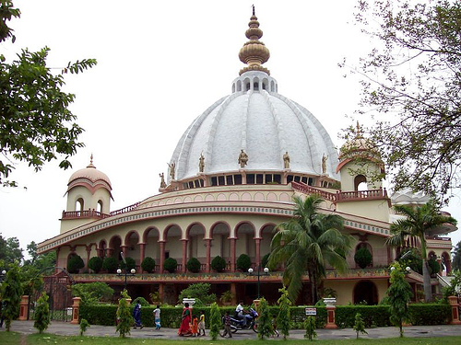
ISKCON, Mayapur, West Bengal, India. ISKCON HQ.
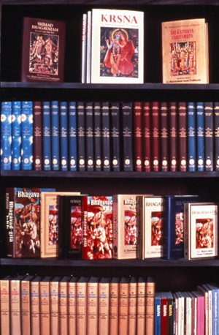
Books by Srila Prabhupada.
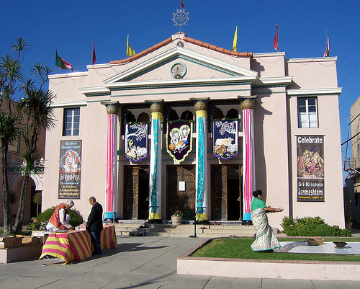
ISKCON, Los Angeles, California, US.
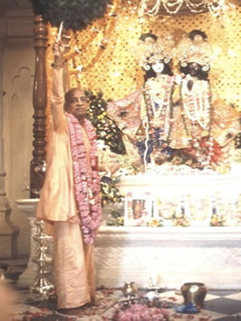

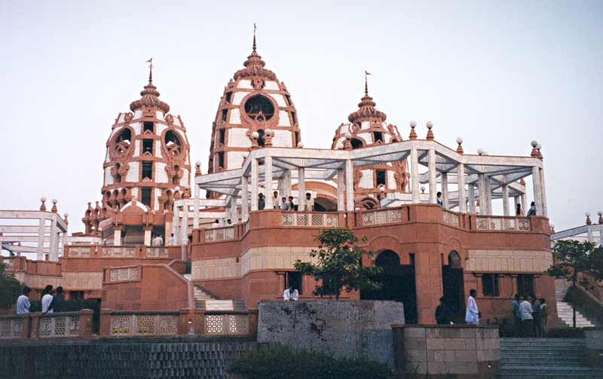
ISKCON, New Delhi, India.

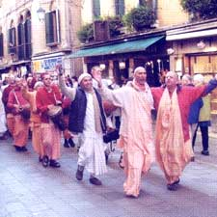
ISKCON devotees street chanting in London, U.K.

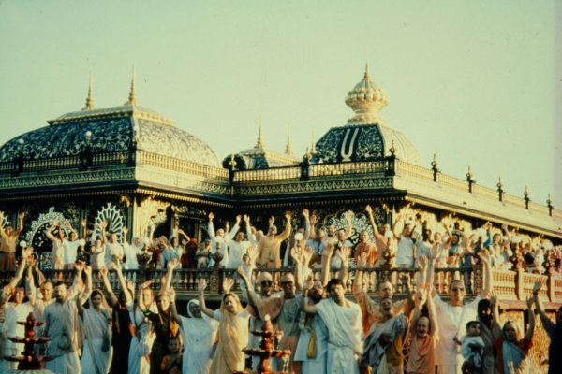
ISKCON, New Vrindavan, West Vegirnia, U.S.

6 Final years and His legacy.

In 1973, Srila Prabhupada came to New Delhi, India along with his American devotees. He had brought them along with him to show the materialistic population of India that how foreigners had benefitted from the timeless teachings of Vaishnava Aachryas and adoptation of the culture and traditions of Bharata Varsha. People in India, were immitating the westerners materially. But now they would be immitating them spiritually. Srila Prabhupada had told his diciples that, they were his “white elephants” whom he was taking to India for setting an example before the bewildered materialists.
Having arrived in India, Srila Prabhupada soon began the respiritualization drive across the country by delivering discourses, promoting book distributions and setting up temples such as Sri Sri Radha Rasbihari Mandir in Juhu, Bombay in 1973. He visited Sri Dham Mayapur and envisioned a major cultural centre there, which has today become a reality. It was in Mayapur, where during one of his early morning walks, he saw some children fighting for a piece of bread with dogs. He immideately told his diciples that within a ten mile radius of a Krishna temple, no one should go hungry. That was the beginning of what is today known as the Sunday mid day meal programme of ISKCON, where devotees distribute prasadam to the poor and malnurished people.
After the successful establishment of the Hare Krishna Movement in India, Srila Prabhupada returned to Vrindavan, the place he had left in 1965 to preach Gaudiya Vaishnavism in the west. A marvellous Krishna Temple was constructed and Srila Prabhupada lived his final days there. He continued preaching, delivering discourses on the Bhagavad Gita and Srimad Bhagavatam and guiding his diciples in every day affairs. He left for Golok Vrindavan on November 14th, 1977. It was a terrible loss to human society as the one who had shown us the transcendental path of Bhakti, had departed to render his personal services to Lord Sri Krishna.
But he told his diciples, that he would always be with them through his books. Indeed, he is always with us. Guiding us by his teachings in his books, discourses and personal examples. Even while lying on his death bed and knowing that he shall soon be leaving this material world for beginning his spiritual life in Golok Vrindavan, he held the hand of one of his diciples and said to all assembled diciples that, “ the understanding that everything is moving at the will of Lord Krishna is Krishna Consciousness.” Thus, even at the moment of death, he considered it as his duty to guide his diciples and set a example for them to follow in the path of Krishna Consciousness. Since it is believed that the final rites of the material body are already done during initiation, a swami’s body is not cremated after death. It is burried. Hence, a samadhi (final resting place) was constructed at the ISKCON Temple in Vrindavan known as the Pushpa Samadhi (Lotus resting place) which is in the shape of a lotus flower. This is where thousands of devotees come every year to pay their love and respect to Srila Prabhupada who has left behind a legacy of devotional service to Lord Sri Krishna!
Hare Krishna!
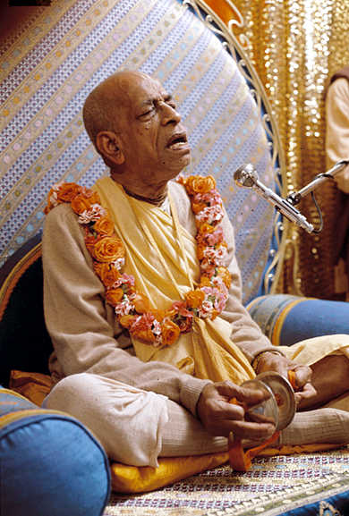
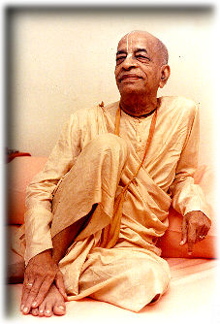
His Divine Grace, A.C. Bhaktivedanta Swami Prabhupada

Dedicated in the loving devotional service of Lord Sri Krishna and Srila Prabhupada.

Written, Edited, Published and Distributed by,
Govardhanagirivaradhari Das (Vinay. D. Chakraborty)

For subscription to free monthly editions, write into vinay.chakraborty@yahoo.com or visit www.soldiersofgodhead.yolasite.com

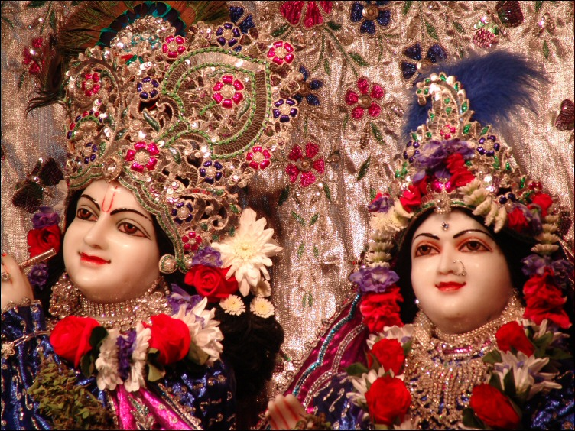
ISKCON, London, U.K. Sri Sri Radha Krishna Mandir.

